**Exploratory Data Analysis**

**Project Name: statistical machine learning Team ID : PNT2022TMID04163**

**approaches to liver disease prediction**

**Exploratory Data Analysis**

Exploratory data analysis is an approach to analysing data sets to summarize their main characteristics, often with visual methods and used for determine how best to manipulate data sources to get the answers you need, making it easier for data scientists to discover patterns, spot anomalies, test a hypothesis, or check assumptions.

**head()** :To check the first five rows of the dataset, we have a function called **head( ).**

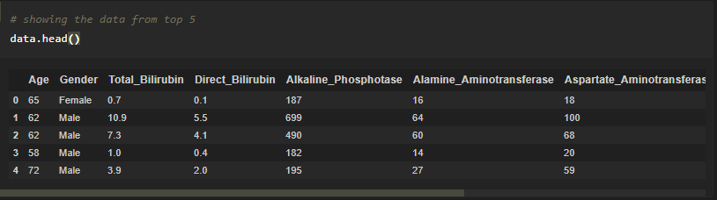

**Tail():** To check the last five rows of the dataset, we have a function called **tail().**

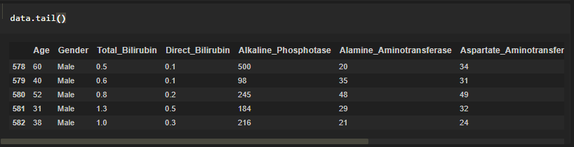

**Understanding Data Type and Summary of features**

* Numeric data types include integers and floats.
* Text data type is known as Strings in Python, or Objects in Pandas. Strings can contain numbers and / or characters.
* or example, a string might be a word, a sentence, or several sentences.

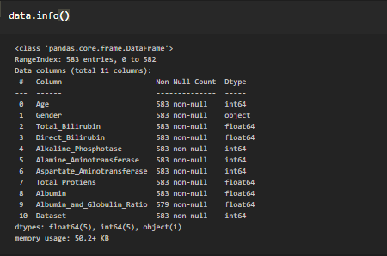

**describe():** functions are used to compute values like count, mean, standard deviation and IQR(Inter Quantile Ranges) and give a summary of numeric type data.

https://lh5.googleusercontent.com/Mquoi2KA_ZyIfd3rj8YdDDp2hDf155BAPe5R7JZ7ZHXVsgbIVpRleK7ZoodBQaaNdx_be3j_moF_cggEObD1811rhFc9Z0pfUGnX69tbOouqA7CDB-OkdS6ObQLsFeV_FwgTUBI=s1600

